**Chatbot Using Artificial Intelligence**

**CSCE 5222 Feature engineering**

**Leela Varadatta Sai Addanki (11617487)**

**Sai Karthik Poojari (11518167)**

**Introduction:**

Artificial intelligence chatbots are chatbots that have been trained to conduct conversations that resemble those of a human using a method called natural language processing (NLP). NLP enables the AI chatbot to comprehend written human language, allowing them to function mostly independently.

In other words, AI chatbot software can comprehend language other than pre-programmed commands and responses depending on the information already in the system. This enables users to take the initiative and express their intentions in their own terms.

An AI chatbot's basic function is to comprehend and transform incoming data into pertinent outputs. In order to provide the optimal response, the AI chatbot will first attempt to understand the question's intent before looking at other aspects like tone and sentiment. The AI chatbot requires access to a tonne of conversational data to do this. For this reason, a programmer must teach AI chatbots how to comprehend the context of a person's statements during a training phase. This comprehension enables the chatbot to provide complicated answers in a way that seems natural and conversational.



**Importance:**

Chatbots are capable of automating routine and scheduled activities. Customers won't have to wait for replies because of this, which provides staff members more time to concentrate on higher priority work. proactive client engagement. Chatbots can shorten line wait times for clients. Instead of waiting for an email, phone call, or response from another channel, people may obtain quick answers to basic queries (such order status, store hours, or locations) via a chat window. supplying leads to agents. Businesses may increase consumer engagement by using chatbots. Engagement may be pushed based on user data and made more engaging by deploying conversational AI chatbots. Additionally, since bots may provide regular responses, you can avoid giving clients useless information. Customers are more satisfied and trusting of chatbots when they resemble humans, which increases chatbot adoption. The findings of this study suggested that there is a strong likelihood that chatbots and customer loyalty are related. Additionally, some clients experience the privacy dilemma as a result of personalisation.

**Approach:**

A chatbot that relies on retrieval employs predetermined input and response patterns. After that, it chooses the right response using a heuristic method. Goal-oriented chatbots are frequently created using this technique, and we may alter their tone and natural flow to provide our consumers with the greatest possible service.

Generic models don't rely on any predetermined answers. Seq 2 Seq neural networks serve as their foundation. The concept is similar to machine translation. Unlike machine translation, where we convert source code from one language to another, here we will convert input into output. It is based on Deep Neural Networks and requires a lot of data.

**Dataset Used:**

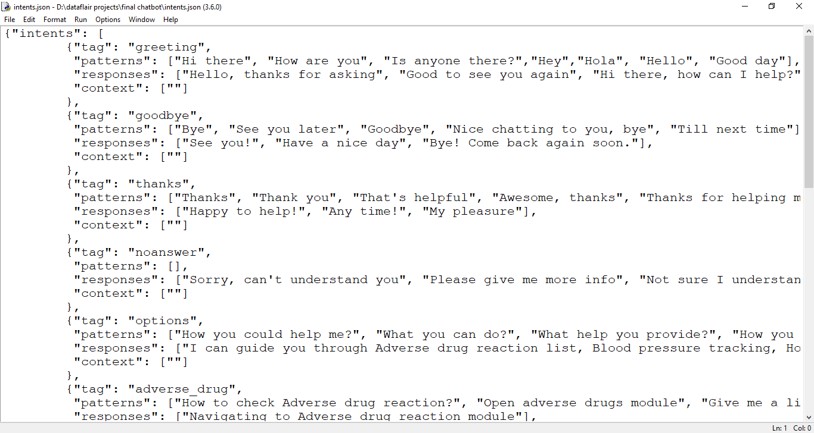

**Steps:**

1. Import and load the data file. Create intents.
2. Preprocess data.
3. Create training and testing data.
4. Build the model.
5. Predict the response (Graphical User Interface).
6. Run the chatbot.

**Related Work:**

Most of the time, obtaining all the data on a single interface is hard without the hassle of navigating through several forms and windows. By offering a standard and user-friendly interface to address questions from college students and professors, the chatbot for colleges attempts to eliminate this challenge.

A chatbot system's goal is to mimic a human conversation. Its design combines a computational algorithm and language model to simulate online information exchange between a human and a machine using natural language.

Today, artificial intelligence research is arguably the most fascinating and difficult area of study. It has already demonstrated its ability to resolve some of humanity's most pressing issues. Artificial intelligence (AI) will soon take up more space and be integrated into our daily lives. However, it is necessary to constantly seek out fresh suggestions for improvement and to advance already planned research. Then, as human intellect is prone to error, we will look forward to using intelligent systems to solve such difficulties. The study presented a different theoretical framework for machine intelligence. The initial research may be expanded upon to create cutting-edge AI theories and systems.

**References:**

1. Yuhua Li, David McLean, Zuhair A. Bandar, James D. O’Shea, Keeley Crockett, “Sentence Similarity Based on Semantic Nets and Corpus Statistics”, IEEE Transactions on Knowledge and Data Engineering, Volume 18 - No. 8, August 2006.
2. Emanuela Haller, Traian Rebedea, “Designing a Chat-bot that Simulates an Historical Figure”, IEEE Conference Publications, July 2013.
3. B. A. Shawar and E. Atwell, “Chatbots: are they really useful?”, LDV Forum, vol. 22, no. 1, (2007)
4. A. M. Turing, “Computing Machinery and Intelligence”, Mind, (1950), pp. 433-460.
5. A. Khanna, “Pandorabots Chatbot Hosting Platform. SARANG Bot”, (2015) April 19, Internet: http:// pandorabots.com/pandora/talk?botid=9f0f09a71e34dcf8/.

GitHub URL: <https://github.com/LeelaVaradattaSaiAddanki/ChatBot_Using_AI>